**SQL SCHEMA**

**1 The create command is used to create a table**

CREATE table airport

(Quarter varchar(50),

`Date recorded` DATE,

`Departure time` time,

`Ground transportation to/from airport` int(1),

`Parking facilities` int(1),

`Parking facilities (value for money)` int(1),

`Availability of baggage carts` int(1),

`Efficiency of check-in staff` int(1),

`Check-in wait time` int(1),

`Courtesy of of check-in staff` int(1),

`Wait time at passport inspection` int(1),

`Courtesy of inspection staff` int(1),

`Courtesy of security staff` int(1),

`Thoroughness of security inspection` int(1),

`Wait time of security inspection` int(1),

`Feeling of safety and security` int(1),

`Ease of finding your way through the airport` int(1),

`Flight information screens` INT(1),

`Walking distance inside terminal` int(1),

`Ease of making connections` iNT(1),

`Courtesy of airport staff` int(1),

`Restaurants` int(1),

`Restaurants (value for money)` int(1),

`Availability of banks/ATM/money changing` int(1),

`Shopping facilities` int(1),

`Shopping facilities (value for money)` int(1),

`Internet access` int(1),

`Business/executive lounges` int(1),

`Availability of washrooms` int(1),

`Cleanliness of washrooms` int(1),

`Comfort of waiting/gate areas` int(1),

`Cleanliness of airport terminal` int(1),

`Ambience of airport` int(1),

`Arrivals passport and visa inspection` int(1),

`Speed of baggage delivery` int(1),

`Customs inspection` int(1),

`Overall satisfaction` int(1)

);

**2.The count function is used to count the number of rows in the data set.**



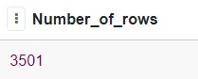

**3. The sum function is used to add all the records in a column. The group by function will group the records having the same value in the mentioned column. The DESC function is used to arrange the values in descending order.**

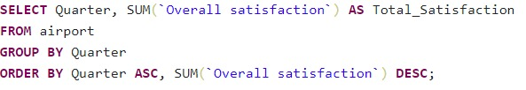

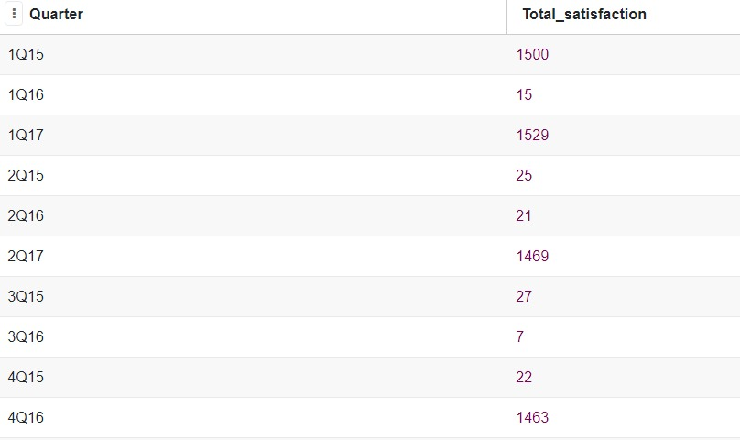

**4. The sum function is used to add all the records in a column. The group by function will group the records having the same value in the mentioned column.**

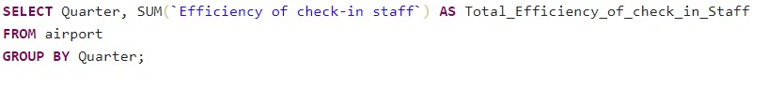

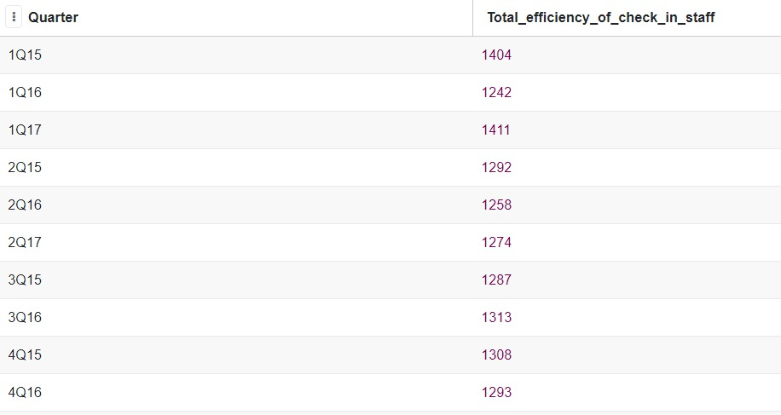

**5**. **The AVG function is used to find the average of the values in the give column. The group by function will group the records having the same value in the mentioned column.**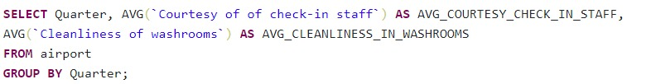

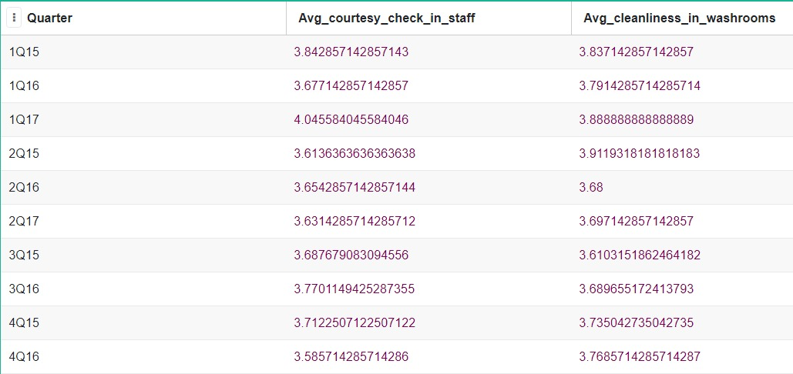

**6. The count function is used to count the number of rows in the data set. The group by function will group the records having the same value in the mentioned column.**

